**ASSIGNMENT-1**

**TECHNOLOGY: Applied Data Science**

**DOMAIN: Food Safety**

**TITLE: Demand Est-AI Powered Food Demand Forecaster**

**Question.1**

**Write a program which will find all such numbers which are divisible by 7 but are not a multiple of 5, between 2000 and 3200 (both included). The numbers obtained should be printed in a comma- separated sequence on a single line**

**SOLUTION:**

**PROGRAM:**

**I**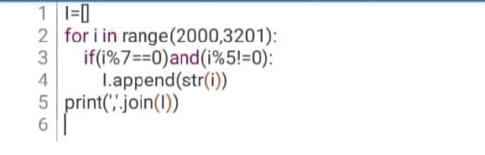

**OUTPUT:**

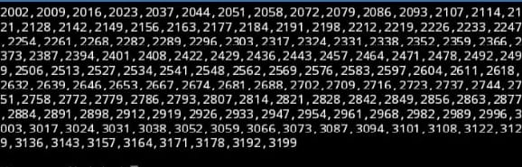

**QUESTION.2**

**With a given integral number n, write a program to generate a dictionary that contains (i, i*i) such that is an integral number between 1 and n (both included). and then the program should print the dictionary.Suppose the following input is supplied to the program:8**

**Then, the output should be:**

**{1: 1, 2: 4, 3: 9, 4: 16, 5: 25, 6: 36, 7: 49, 8: 64}**

**PROGRAM:**

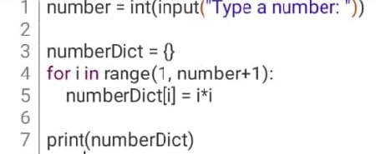

**OUTPUT**:

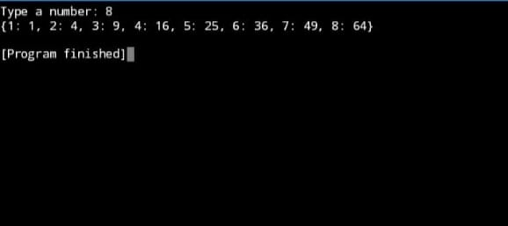

**TEAM LEADER: GAYATHRI.P**

**TEAM MEMBERS:**

* **MAHALAKSHMI.S**
* **RAJESWARI.R**
* **PEACHIAMMAL.S**

**TEAM ID: PNT2022TMID37970**

**TEAM SIZE: 4**

**TEAM MENTOR: SUBBURAM.S**